NIT KARNATAKA



THE DARK SIDE OF SOCIAL MEDIA

A CS709 SEMINAR REPORT

SUBMITTED BY

SATYAM PRAKASH (202CS027)

DEPARTMENT OF COMPUTER SCIENCE AND ENGINEERING

NATIONAL INSTITUTE OF TECHNOLOGY KARNATAKA

P.O. SRINIVASNAGAR, SURATKAL, MANGLORE – 575025

KARNATAKA, INDIA

JANUARY 2021

Abstract
Using social media websites is one among the foremost common activities in today’s world. The aim of social media is to provide users a platform to connect with others. Such sites offering communication and entertainment have grown exponentially in recent years. Research and analysis have largely focused on the bright side of social networking. However, it is more and more evident that social media present enormous risks for people, communities, firms, and even for society as a whole. Examples for this dark facet of social networking embody addictive use, cyber bullying, trolling, fake news, negative comments, privacy abuse etc. Multiple studies have found a strong link between heavy social media and an increased risk for depression, anxiety, loneliness, self-harm, and even suicidal thoughts. These worsening symptoms cause you to use social media even more, and so the downward spiral continues. Users even don’t understand that these effects are due to social networking. People spend longer time on these sites than with real friends, they have no time for self-reflection, they engage in risky behaviour in order to get likes, suffer sleep problems etc. It also has impact on Politics because many people get their news from social media, so political parties run campaign to polarize people using social media like Cambridge Analytica data scandal. The aim is to illustrate the multidimensionality of the dark side of social networking and describe the related various undesirable outcomes. To do this, we adapt the established social media honeycomb framework to explain the dark side implications of each of the seven functional building blocks: conversations, sharing, presence, relationships, reputation, groups, and identity. On the basis of these reflections, we present a number of avenues for future research, thus to facilitate a higher understanding and use of social media.

TABLE OF CONTENTS

- Introduction
- Problem
- Significance of problem
- Existing solution
- Research gaps
- Future research direction
- Conclusion
- References

INTRODUCTION
Over the past decade, social media have been transforming how individuals, communities, and organizations create, share, and consume information from each other and from firms. What appeals to almost 90% of the younger EU citizens is how social media differ from traditional media (e.g., newspaper and television) in terms of their reach, interactivity, usability, and ubiquity. In 2017, users spent more than 2 hours on average per day on social networks and messaging services (half an hour each day longer than five years earlier), which amounted to about one third of their entire daily computer time.
Social media is of many types, some of them are:
- Social networking sites such as Facebook, Twitter, LinkedIn etc.
- Image sharing and messaging sites such as Instagram, Snapchat, Pinterest, Imgur etc.
- Video sharing sites such as YouTube, Vimeo etc.
- Social community and discussion sites such as Reddit, Quora, Yahoo!Answers etc.
Many studies have touted the advantages that social media would bring to individuals and firms. They highlight the “bright side of social media” and how engagement between firms and consumers is being democratized. For firms, this means social media would improve marketing, public relations, customer service, product development, personnel decision-making, and other business activities that rely on information exchanges and engagement with consumers and employees. Many of these advantages have materialized, thus leading almost 50% of all EU firms to use at least one form of social media in 2017. These firms use social media to not only broadcast company content but also track sentiment worldwide by analyzing user generated content, consumer-generated intellectual property, and interactions on social networking sites, to adjust their business and marketing strategies appropriately.
Regardless of the numerous opportunities social media offer, an increasing number of incidents demonstrate that there is undoubtedly a “dark side” to social media. Chamath Palihapitiya, a former Facebook executive, recently stated that “he regrets that some of the tools he has helped to create “are ripping apart the social fabric of how society works”. This quote vividly illustrates how the qualities that underlie the enormous presence of social media platforms are now also undermining the freedoms and the well-being of the individuals and communities they serve. For example, there have been an increasing number of reports and research attention into concerns such as cyber bullying, trolling, privacy invasions, fake news, online firestorms, and addictive use. Furthermore, a 2017 survey found that Britons aged 14e24 believe that social media, such as Facebook, Instagram, Snapchat, and Twitter, exacerbated self-consciousness and “fear of missing out”, which can result in increased levels of anxiety, sleep loss, and depression. In the workplace, a recent study found that the benefits of social media also come with negative consequences through work-life conflicts and interruptions that increase exhaustion.
Even with social media executives admitting that their platforms have deleterious impacts; users tend not to question the short-term and long-term implications and potential risks of their choices. Many company employees and customers now belong to a generation of digital natives who have grown up with social media, rather than first learning to use these technologies as adults. Most adult users, too, have become so accustomed to social media that the types of conversations, self-expression, community building, and other forms of online engagement are now parts of the only reality they know. It is therefore of utmost importance to take a step back to reflect on how we have arrived at the present and what our most recent social media “advances” might mean for us in the future.

PROBLEM
Around 40% of the world’s population use online social media and spending an average of two hours every day sharing, liking, tweeting and updating on these platforms and likely face problems. Multiple studies have found a strong link between heavy social media and an increased risk for depression, anxiety, loneliness, self-harm, and even suicidal thoughts.
Some of the problems associated with usage of social media are as follows:
1) Spending Too Much Time On Social Media
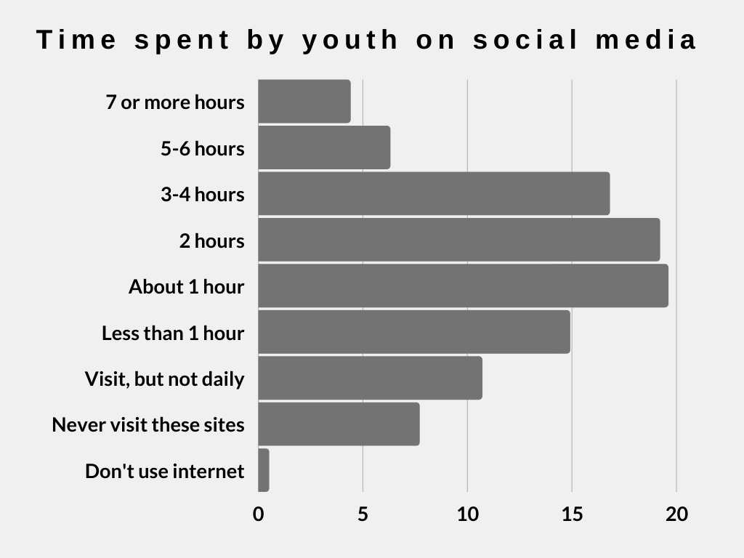
The majority of students in grades 7-12 visit social media daily. About 1 in 10 students spend five hours or more in these sites daily. 32% of students in grade 4-6 have Facebook account and 16% have Twitter account.
On average, we spend 144 minutes, or two hours and twenty-four minutes, on social media but this number is just that – an average. In some places in the world, people spend far more time on social media, and in others, they spend far less.

Additionally, the time people spend on social media each day has been growing since 2012. There's no way to predict the future, but we expect that in 2020 and beyond, the global average will likely rise, especially since the number of internet and social media users around the world continues to grow.
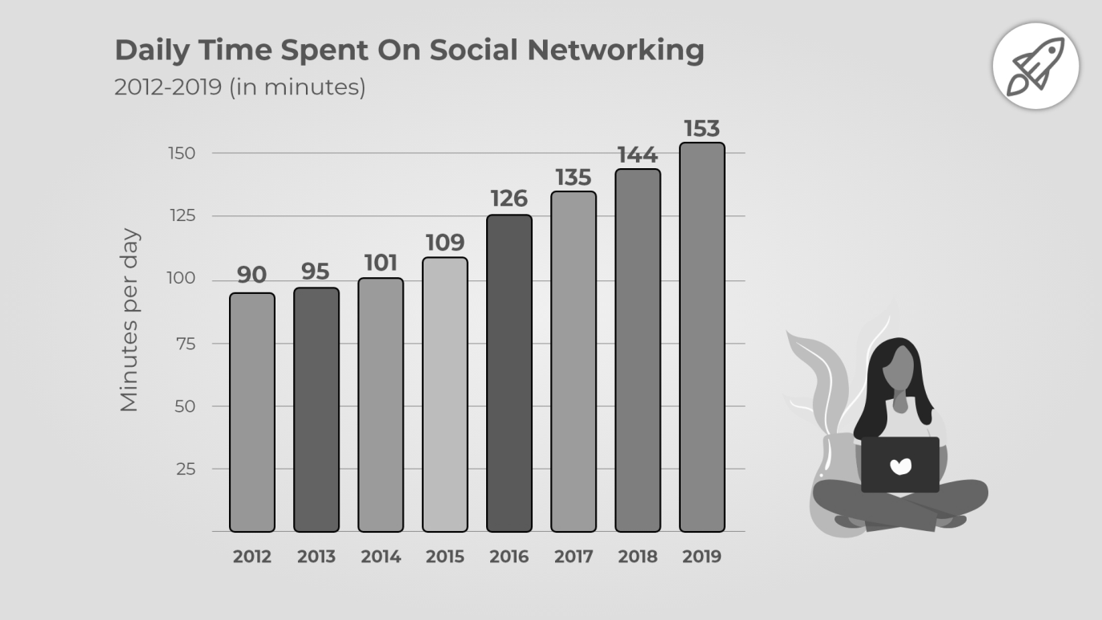

2) The FOMO Syndrome
FOMO stands for Fear Of Missing Out. It is a social anxiety originating from the belief that others might be having fun while the person experiencing the anxiety is not present. It involves a deep sense of envy and affects self-esteem.
Studies show that FOMO leads to extreme dissatisfaction and has a detrimental effect on our physical and mental health – mood swings, loneliness, feelings of inferiority, reduced self-esteem, extreme social anxiety, and increased levels of negativity and depression. It is not surprising that the use of anti-depressants has risen sharply in recent years due to FOMO.

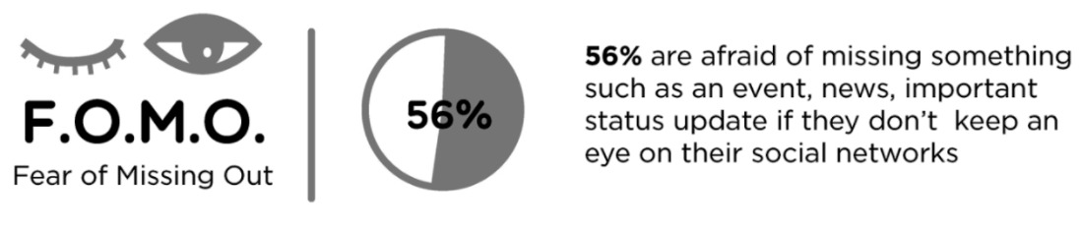
It is important to know that FOMO may be worsened by the fact that we are being constantly reminded about what we are missing out on via all the notifications we receive to our phones. One potential strategy to curb FOMO may be to manage which notifications we want to receive.
3) Reduced Attention Span
Attention span is the amount of time spent concentrating on a task before becoming distracted. Distractibility occurs when attention is uncontrollably diverted to another activity or sensation.
National Centre for Biotechnology Information claimed that the average human attention span has dropped from 12 seconds in 2000 to 8 seconds in 2013 (just one second below that of a goldfish).
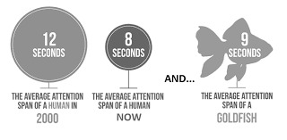
4) Reduced Productivity
The use of social media in the workplace, and the resultant slacking (neglecting work) is more rampant today than ever.
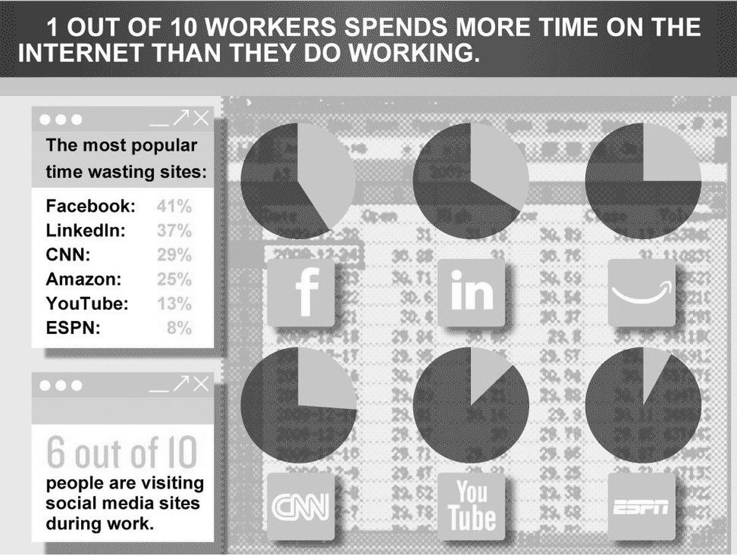
Mashable reports that a social media interruption occurs every 10.5 minutes on average, and it then takes 23 minutes for those users to get back on task. Facebook is the most visited social media platform and the most-handy outlet to relieve stress. Out of the 62% employees who accessed social media during working hours, nearly 83% of them spend significant time browsing on Facebook.
5) Neglecting Relations and Responsibilities
As Old saying goes - We shape our tools. But in the modern context, we are shaped by our tools. We are all so pre-occupied with our computers that we have forgotten human interaction in the real world. Social networking platforms drove man closer to those in neighbouring continents, while driving him further apart from those in his neighbourhood. The present day humans are so hooked on to their devices and its content that they have become more social online but pitifully less or nil interaction offline. Chances are that speaking one’s mind online will ave the same after effects as saying those same things face-to-face and internet users have happily incorporated this element of social media.
Most often technology can bring forth negative interaction, or zero interaction between siblings, couples, or parent-child. It starves the family of learning and modelling with each other social cues, interpersonal relationship skills, communication skills, and bonding. Studies have shown that as parents increase screen time, so do children. Screen time in these studies included smartphones, television, computers, and video games.
5) Privacy Issues
Online social media can introduce new threats for their users because of potential for accessing a vast amount of personal information disclosed by users themselves. Criminals are expert at tricking social media users into handing over sensitive information, stealing personal data, and gaining access to accounts which users consider private. Many social media apps monitor your profile activity, collect your interests, likes and dislikes, and then create a tailored experience for you.
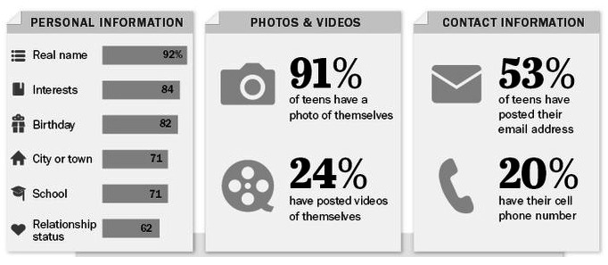
Percent who share information on the profile they use most often
Advertisements may sound harmless, but the fact that someone is collecting your browsing activities across other websites should be alarming for you. It indicates that even your private activity online is not private, and that whatever you do on social media is seen by the app developers and is gathered to create better marketing campaigns.
6) Anxiety & Depression
Excessive use of social media can fuel feelings of anxiety and depression. The greater we use social media, the less happy we seem to be. One study discovered that Facebook use was linked to both less happiness and less life satisfaction.
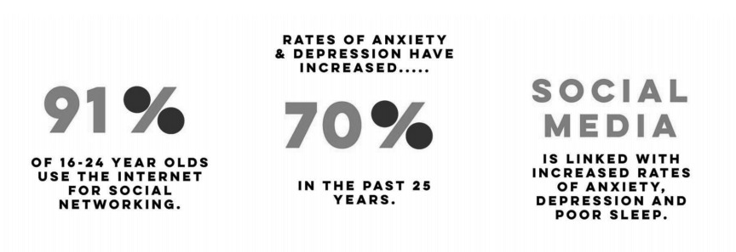
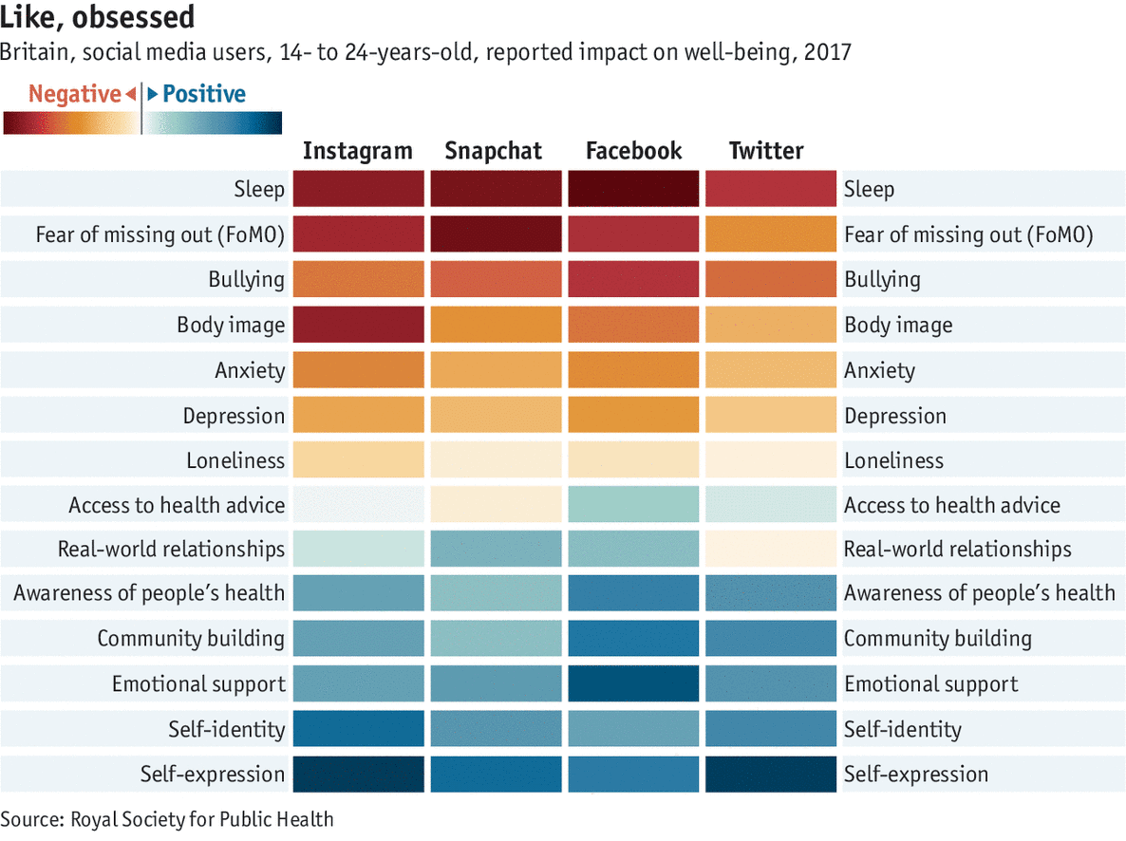For individuals with depression or anxiety, the interpretation and frequent exposure to this emotion may have a negative impact. SNS use may increase an individual’s exposure to negative social interactions (e.g. cyber bullying), which may negatively impact mood and mental health.
7) Addiction
It is generally defined as the compulsive use of social media platforms that results in significant impairment in an individual's function in various life domains over a prolonged period. Social media addiction can be viewed as one form of Internet addiction, where individuals exhibit a compulsion to use social media to excess. Individuals with social media addiction are often overly concerned about social media and are driven by an uncontrollable urge to log on to and use social media. Studies have shown that the symptoms of social media addiction can be manifested in mood, cognition, physical and emotional reactions, and interpersonal and psychological problems.
Many studies on social media usage and mental health have shown that the prolonged use of social media such as Facebook is positively associated with mental health problems such as stress, anxiety, and depression and negatively associated with long-term well-being. For example, the time spent on social media was positively related to depressive symptoms among high school students in Central Serbia and among young adults in the United States. Furthermore, certain categories of social media use have been shown to be associated with reduced academic performance.
Aza Raskin, former Mozilla and Jawbone employee said "Behind every screen on your phone, there are generally like literally a thousand engineers that have worked on this thing to try to make it maximally addicting". He also added “It's as if they're taking behavioural cocaine and just sprinkling it all over your interface and that's the thing that keeps you like coming back and back and back”.

SIGNIFICANCE OF PROBLEM
The dark side of the seven building blocks of social media
To understand how individuals, communities, and organizations can use different social media platforms to connect, monitor, and engage with each other, Kietzmann et al developed a honeycomb framework. This framework unpacks social media functionalities into seven building blocks to describe different features of the social media user experience and the extent to which different social media are driven by each functionality.
These functionalities refer to the extent to which users can (i) converse with each other, (ii) share content, (iii) let others know about their presence, (iv) form relationships, (v) know the reputation of others, (vi) form groups, and (vii) ultimately reveal their identity.
Given the honeycomb framework's usefulness in understanding the functional building blocks of social media, each functional block of the framework can also be used to help to understand and examine different aspects of the dark side of social media. Focusing on the negative consequences that consumers and communities face from social media, we now explain the dark side implications of each functional block.

1) Conversations
This building block refers to the extent to which users communicate with others using a social media platform. Twitter, Facebook, Instagram, LinkedIn, and many other platforms provide the ability to converse with functions such as “Like,” “Reply,” “Comment,” and “Direct Message.” For more detailed conversations, blogs provide a forum for users to post and discuss diary-style commentaries, which readers can then comment on or even add to. Further, Reddit, which at the time of writing this article was ranked the 6th most visited website in the world, is essentially a bulletin board system for over 200 million unique users who each month discuss and vote on content covering a vast array of topics, such as news, entertainment, sport, health, music, and literature.
The dark side of the conversation functionality is that excessive, aggressive, and inaccurate engagement can occur. For example, despite having clear rules and significant moderating resources intended to prohibit harassment, Reddit users can be exposed to threats and bullying. In 2010, a Reddit user who had genuinely donated a kidney made a posting seeking donations to a related charity. Some Reddit users thought this was a scam and contacted the user at his home with death threats.
The dark side of social media functionality

2) Sharing
This aspect of a social media platform concerns the extent to which consumers exchange, distribute, and receive content. Consider for example how people use Flickr to share photos, YouTube to share videos, and Instagram to share photos and videos. Successful social media platforms understand how to build on the user motivations for sharing different content along with the relationships and groups that can be produced from these motivations.
The dark side of the conversation functionality is once users can easily share content; a fundamental risk is that the shared content can be inappropriate and undesirable or that it can be shared without permission from the holder of any intellectual property rights (IPR) associated with the content. In terms of inappropriate content, a survey of 10,000 European children aged 9-16 reported that 40% of children expressed shock and disgust when viewing violent or pornographic content that had been shared by others online.
Conversely, investigations by news agencies revealed that more than 100 websites that posted fake news about the 2016 U.S. presidential election were run by teenagers in the small town of Veles, Macedonia. For IPR infringement risks, consider for example the case of Stephanie Lenz who, in February 2007, posted a 29-second video on YouTube of her baby pushing a toy around the kitchen, while dancing to the song “Let's Go Crazy” by Prince that was being played in the kitchen. In June 2007, the Universal Music Group (Universal), which manages the copyright of Prince's music, decided that the song rather than the dancing baby was the focal content in the video. Universal issued a takedown notice to YouTube, and the video was immediately removed from the website. Lenz disputed the removal of the video and filed a “counter-notice” to YouTube, arguing that no rights of Universal were violated by her video. Universal insisted that sharing the video was wilful copyright infringement and that Lenz was liable to a fine of up to US$150,000.
In sum, it is clear that the powerful and addictive sharing functionality of social media presents risks to those who share content and those who consume the content that is shared.

3) Presence
This functional block concerns the extent to which organizations and individuals know whether, where and when, others are accessible. This includes knowing the presence of others in an online world and/or in the real world. For example, Facebook, Google Maps, and other social media use internet protocol (IP) address information, location information from mobile devices, and “check-in” declarations to monitor where individuals are and possibly allow others to know this information too.
The dark side of this functionality is that the location and availability of users are known and can be tracked without their awareness or consent. For example, in 2011, Facebook launched the Messenger application for mobile devices. From 2011 to 2015, the default settings for this application were to collect and display geolocation information with message content in the conversations.
In 2012, a number of organizations reported privacy concerns about the implication of this geolocation sharing feature of the application, but to no avail. The policy was not changed. Then, in 2015, an extension for the Chrome browser named Marauders Map was developed and made available by a Harvard University computer science and mathematics student. This extension used Messenger data to map, and thus stalk, the identity, locations, and movements of all individuals in a conversation. In the dark side context, the presence building block is very directly tied to issues pertaining to protecting or invading the privacy and possibly the safety of people who engage on social media.

4) Relationships
This building block is concerned with the extent to which users can relate to other users through social media platforms. In other words, users have some form of an association that determines why they engage with each other and the what-and-how of the content they exchange. For example, LinkedIn's 500 million users are largely structured around professional relationships based on who users work for, work with, and where they work. In contrast, Facebook is based on friendships of all kinds, including those based on residential address, educational institutions attended, and associations with “friends of friends.”
When social media help to establish and reveal relationships, they enable different types of social engagement and related deleterious consequences. This includes cyber bullying, stalking, and online harassment, where estimates are that 10-40% of the youth are victims of cyber bullying, and 40% of those who cyber bully report they do so for fun, possibly connected with occurrences of jealousy.
5) Reputation
Reputation is the degree to which users can identify and influence the standing of others, including themselves, in a social media setting. It is a construct that can be viewed in terms of how individuals display competence (functional reputation), demonstrate social norms (social reputation), or appear to be attractive, fascinating, or inspiring (expressive reputation). The reputation of a social media user can be indicated by, for example, the number of followers someone has on Twitter, the sentiments of the comments expressed about a social media user, the view and like counts for a user's YouTube video, or the status some platforms award to users (e.g., the influencer status on LinkedIn).
A major reputation risk stems from sharing inappropriate content, which can destroy the sharer's reputation and/or the reputations of others. Regardless of whether a posting is based on true or false content, the more outrageous the posting, the quicker it tends to spread and harm reputations. Every year, numerous business and political leaders, and others, are forced to resign after posting offensive, disingenuous, or ridiculous content on social media. Despite the long-term consequences of their actions, in an online setting, users revealed that they did not properly think about their reason for posting, misjudged who could be the audience, were highly emotional when posting, or were under the influence of drugs or alcohol.
6) Groups
This building block ascribes the function that social media users can create or join circles of friends or communities centered around a shared practice or interest. On Facebook, people participate in these open or closed groups (or those hidden to non-members) for socializing, entertainment, self-status seeking, and information purposes. Associated benefits for the users are the possibility to organize their growing social network and to allow permissions what content can be accessed by specific (sub)groups, e.g., what photos will be displayed on a contact's timeline on Facebook.
The negative side of the groups building block, for instance, often shows its face through what social psychologists refer to as “ingroup-outgroup bias”. People define themselves in terms of social groupings (ingroup identity). They find themselves in an echo-chamber in which their own beliefs are amplified and reinforced, and those who do not fit into those groups (outgroups) are belittled. The “ingroup love and outgroup hate” can be seen when people not only exclude others from conversations or group membership but also lose empathy for them (i.e., the intergroup empathy gap). The many polarized discussions of racial and gender inequality serve as appropriate examples, as do the recent populist elections, and more generally, the separation of leaders and influencers vs. the general public online.

7) Identity
Presenting one's identity is a central aspect of social media. Next to providing objective personal information, such as gender or age, users can also provide more subjective details that express their identity by, for example, joining groups with a specific topic or by liking, disliking, or commenting on content. Setting up a profile and therefore becoming identifiable is a prerequisite for most social media applications. Although each user can generally decide for him-/herself what kind of personal information they want to share, social media sites have a great interest that users share as much information as possible.
Displaying one's identity online, however, has many downsides. The other building blocks (e.g., the conversations and relationships online, the sharing of images, the location-specific data, the ingroup-behaviour, and the online reputation) have a direct impact of who we are, to our personality and character. The visibility, transparency, permanence, and granularity with which social media content online connects to people's lives offline emphasizes that social media users are not in control of their own identity any longer, thus leading to all sorts of privacy and safety risks. A recent UK study found that the lack of privacy and protection on social media is one major concern of children and young people. Some have even gone so far as to say that stalking others on social media has already become normality.

EXISTING SOLUTIONS

- Regulations: Day by day new regulations are made for social media companies, such as handling of personal data and the accountability of social media platforms where user-generated content is shared.

- Awareness: Creating awareness among users about the potential consequences of their actions on social media is essential. Many dark side social media incidents could be prevented if users were better informed about the real-life consequences of their online actions and the digital traces they leave behind on social media applications.

- Social Media Censorship: Censorship can reduce the impact of hate speech in society, it can protect children from unhealthy content, it protects the rights of artists, innovators, and inventors. It provides another level of security to a country’s profile.

- Mitigate distractions: Turn off pop-up notifications and other alerts that pull you into social when you have other things to focus on.

- Parents need to ensure that their children have adequate social interactions face to face.

- Screen time should be limited as much as possible so that children and teenagers can spend more time with their family and real-life friends.

- The important thing for parents is to maintain communication with their children to remind them how precious they are.

RESEARCH GAPS

Much of the research related to Dark side of Social Media has focused on multidimensionality of the dark side of social media and describe the related various undesirable outcomes based on social media honeycomb framework (functionality of a social media site) to explain the dark side implications of each of the seven functional building blocks: conversations, sharing, presence, relationships, reputation, groups, and identity. However, research is lacking on study on larger samples of people which are representative of a broader population in order to increase the respective study’s external validity.

FUTURE RESEARCH DIRECTIONS

- The intention of this report was to illustrate the seven building blocks of the dark side of social media, in great part to motivate further research that tries to untangle the underlying mechanisms in new ways. Existing theories cannot necessarily be transferred to the social media sphere. New theories, or combinations of existing theories, might better suit the inherent characteristics of social media, a close example is Scheiner, C. W., Kramer, K., & Baccarella, C. V. (2016). Cruel Intentions? - the role of moral awareness, moral disengagement, and regulatory focus in the unethical use of social media by entrepreneurs who base their theoretical framework to explain unethical behaviour on social media by entrepreneurs on the concept of moral disengagement and regulatory focus theory.
- There is a significant opportunity for future research studies using contemporary methodologies that suit the characteristics of social media. For instance, a recent and effective development for understanding online behaviour might be Netnography (a branch ethnography that analyses the free behaviour of individuals on the Internet that uses online marketing research techniques to provide useful insights.), which allows researchers to study social interaction in modern digital communication contexts.
- Larger Sample size of people of broader population in order to increase the respective study’s external validity if possible.

CONCLUSION

Social networking communities are an intrinsic element of today’s web world. People use these sites as they want to be in touch with friends, exchange pictures or just kill time when bored. Companies too, have started engaging social media as a marketing tool for targeting their customers with relevant information and give more focus to them. many users are still ignorant or rather indifferent towards the security settings provided by the network and expose themselves to the risks that arise out of disclosing too much personal information. Social networks definitely can be definitely be informative and entertaining, but users should exercise caution and behave with the required level of uncertainty.

REFERENCES

- Baccarella, Christian & Wagner, Timm & Kietzmann, Jan & McCarthy, Ian. (2018). Social media? It's serious! Understanding the dark side of social media. European Management Journal. 36. 431-438. 10.1016/j.emj.2018.07.002.
- https://www.statista.com/chart/15720/frequency-of-teenagers-social-media-use/
- https://www.economist.com/graphic-detail/2018/05/18/how-heavy-use-of-social-media-is-linked-to-mental-illness
- Kuss, Daria & Griffiths, Mark. (2012). Online social networking and addiction - A review of the psychological literature.
- Scheiner, C. W., Kramer, K., & Baccarella, C. V. (2016). Cruel Intentions? e the role of moral awareness, moral disengagement, and regulatory focus in the unethical use of social media by entrepreneurs. Lecture Notes in Computer Science, 9742, 437e448.

